 | BAHRIA UNIVERSITY, (Karachi Campus)  Department of Software Engineering  Assignment 1 - Spring 2021

COURSE TITLE: Linear Algebra COURSE CODE: Gsc-121
Class: BSE-2(A&B) Shift: Morning
Course Instructor: Muhammad imran afridi Time Allowed: 2 Days
Submission Date: 31 March 20201 Max. Marks: 5 Marks

Assignment No. 01, (CL01) [5 Marks]

- Solve the linear system by Gauss elimination method.
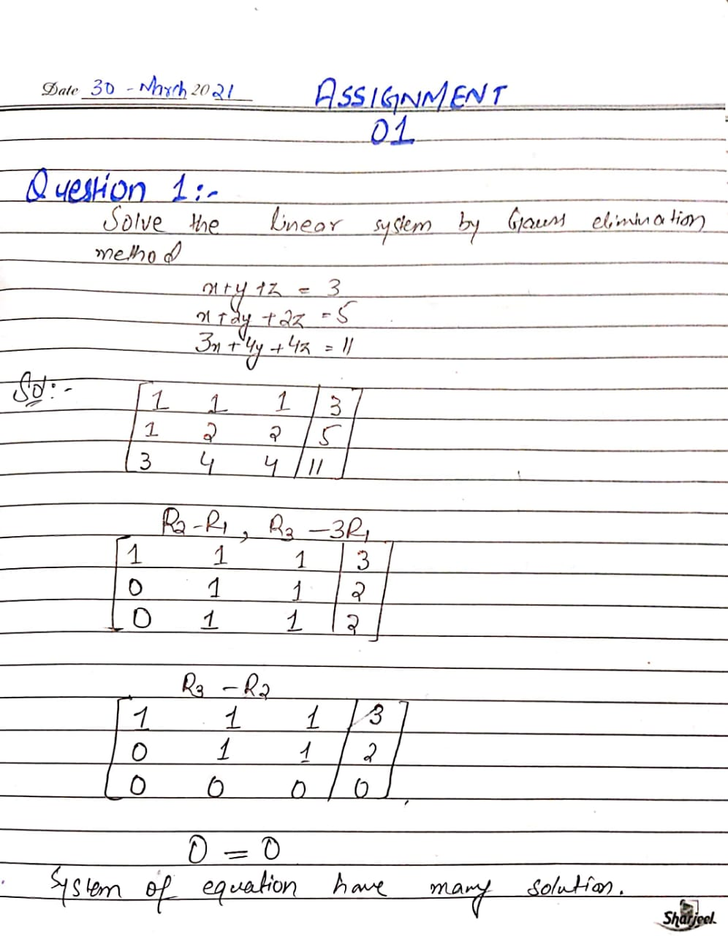
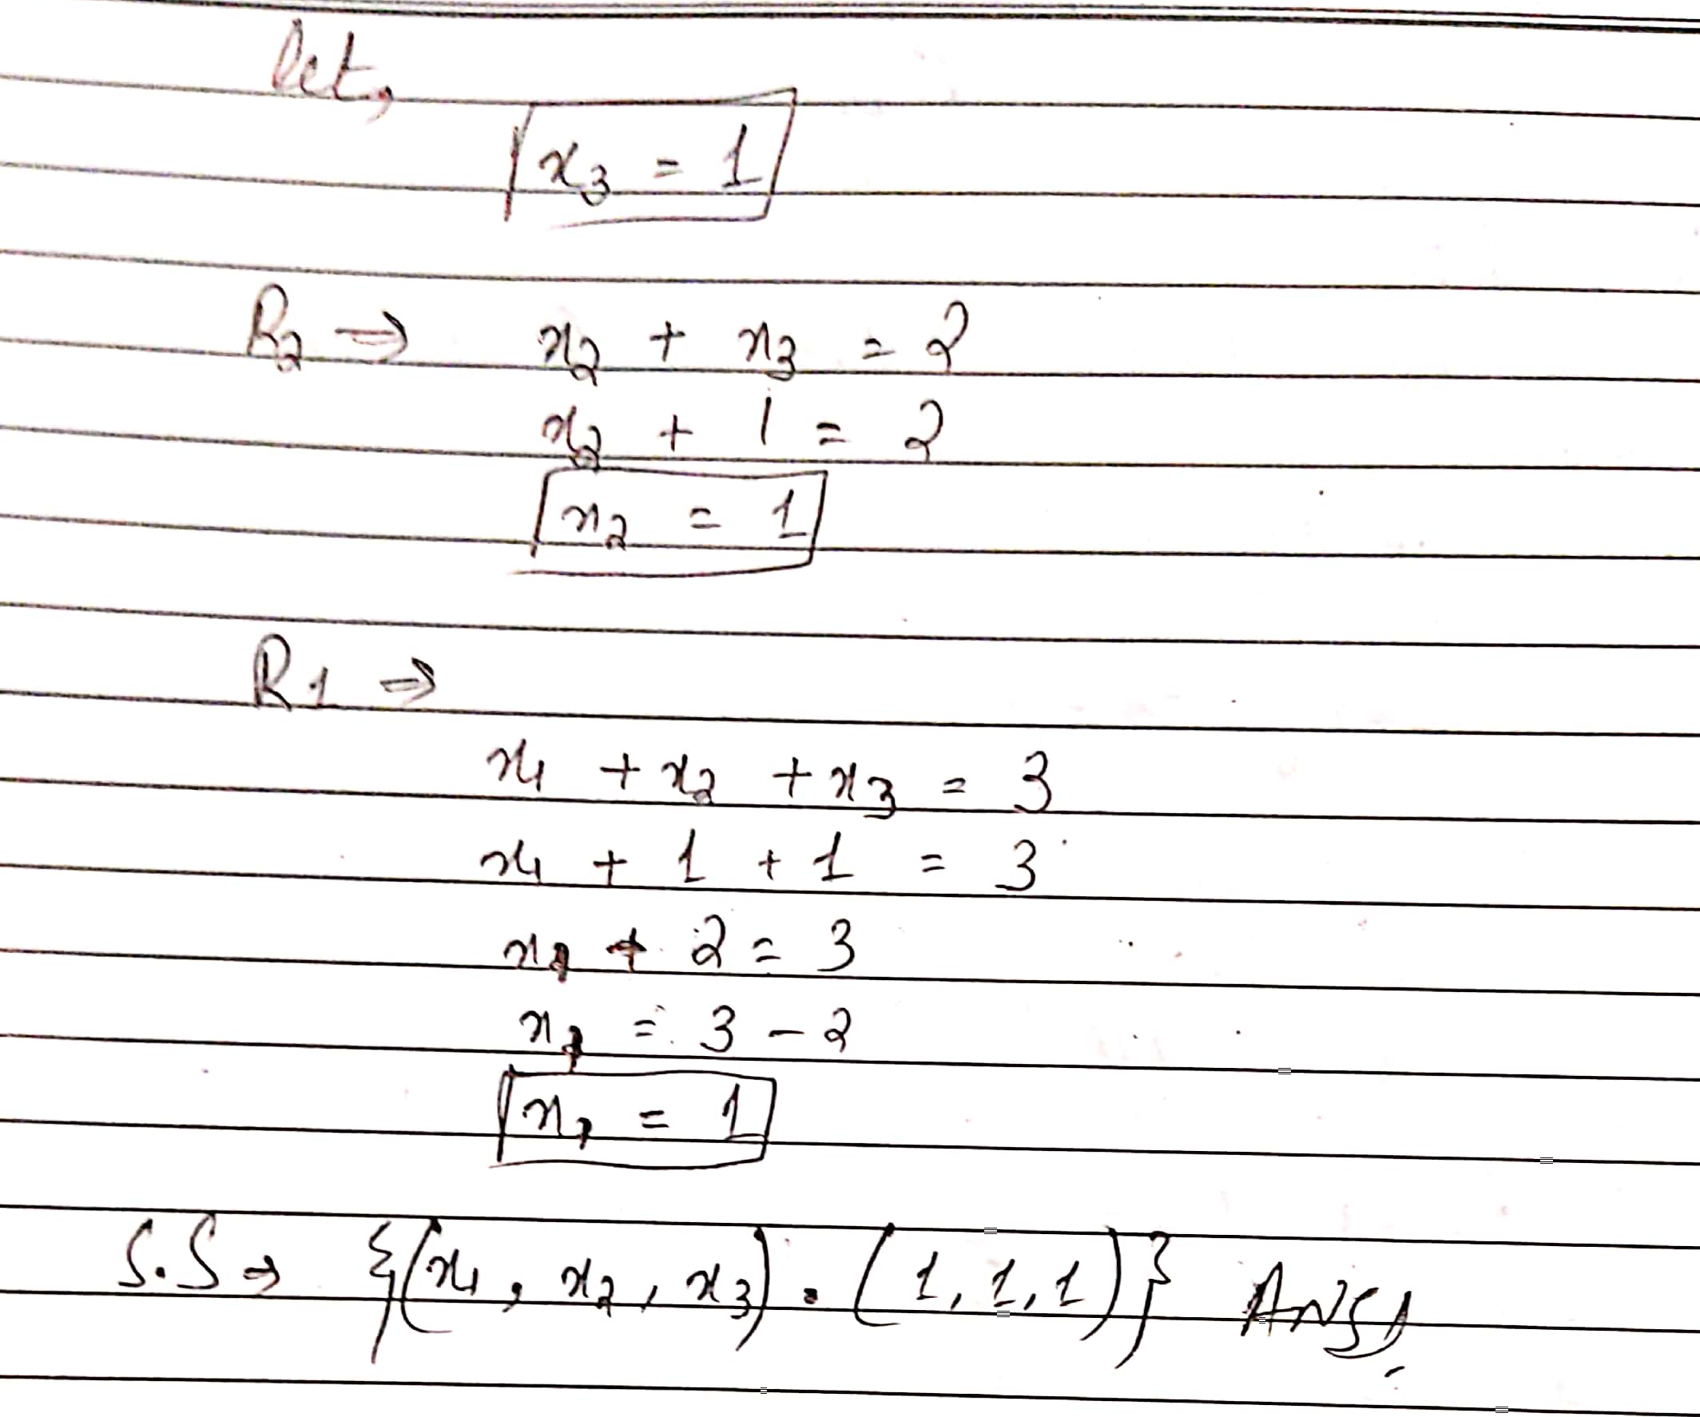
- Solve circuit by using GAUSS-JORDAN METHOD

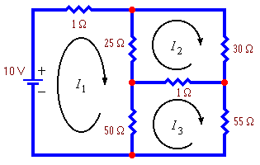

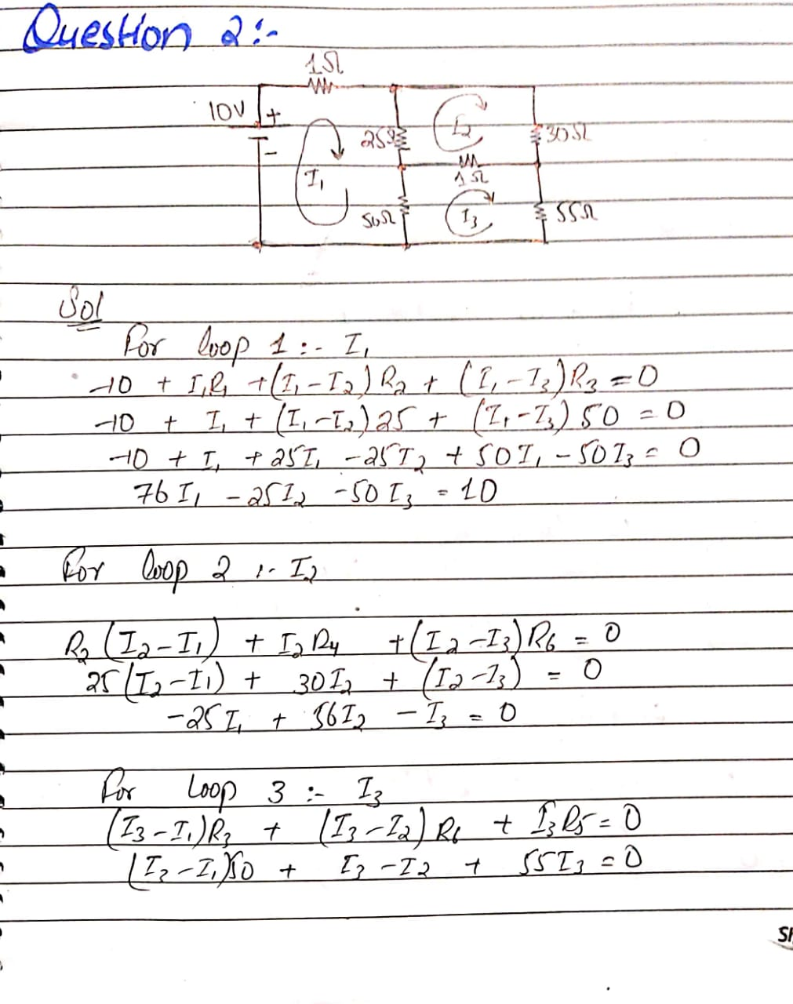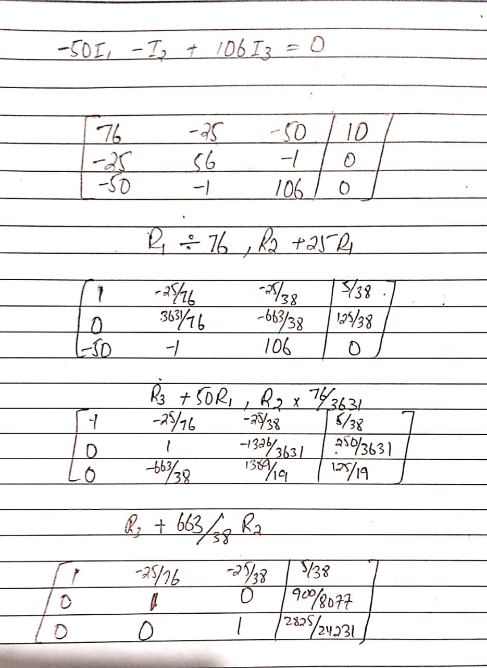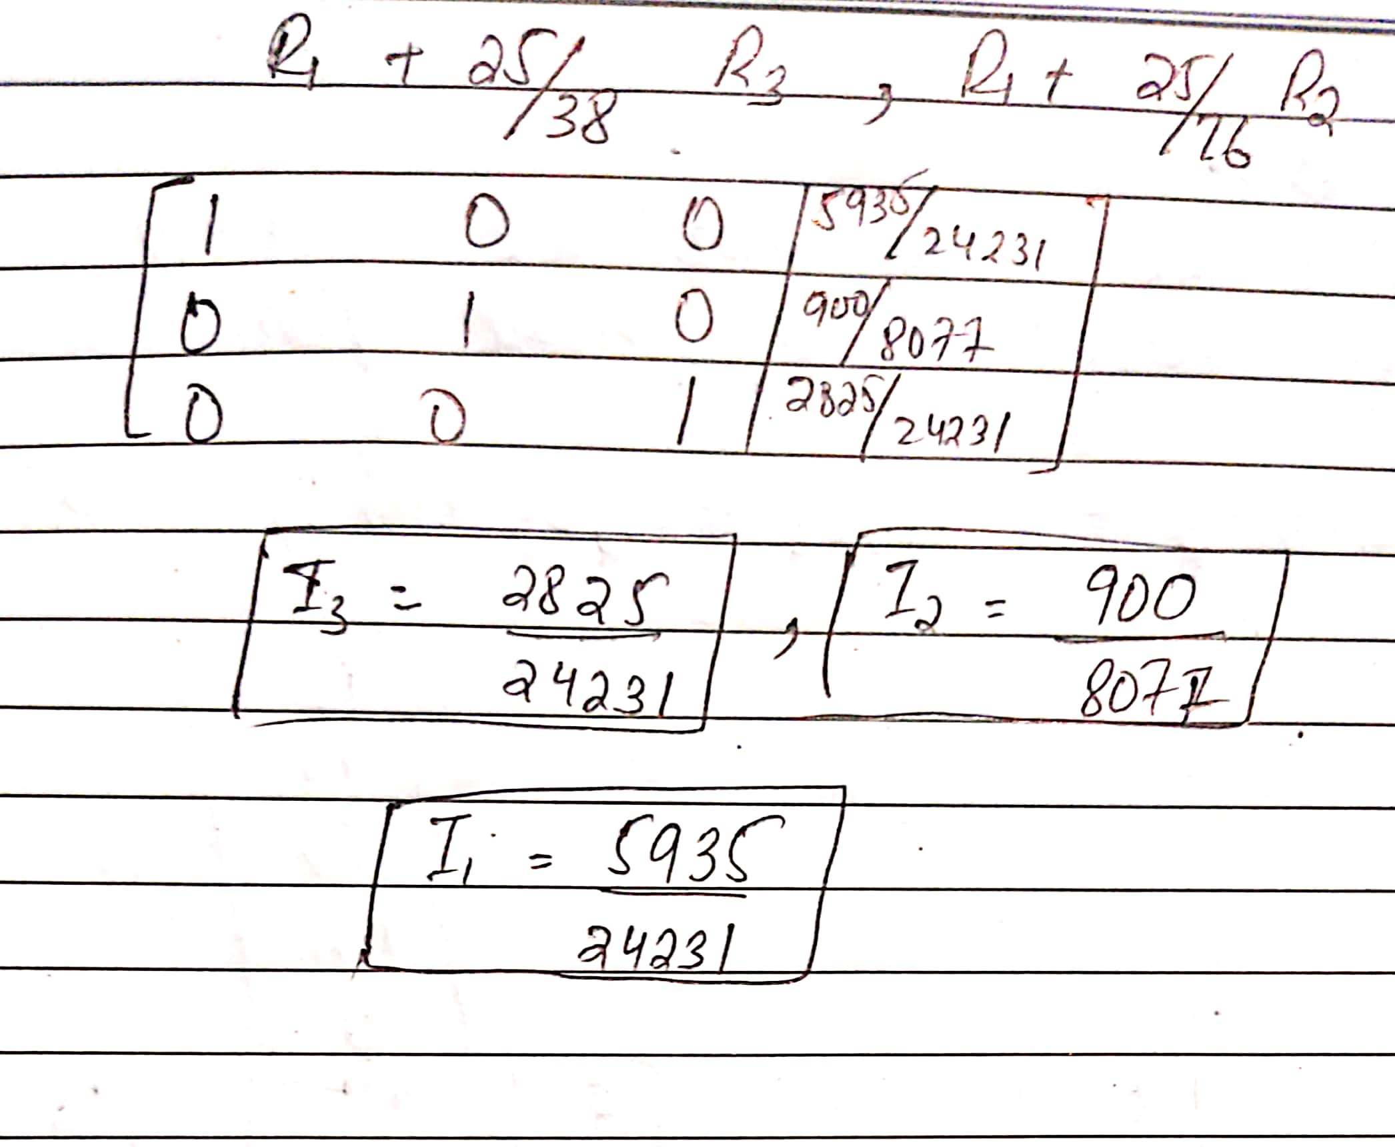

- Balance the given unbalance chemical equation by Row reduction to echelon form.
